**ANOVA & CORRELATION**

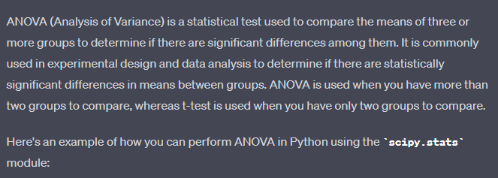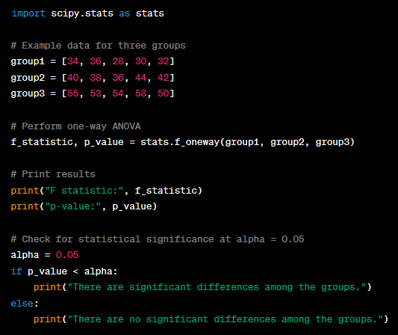

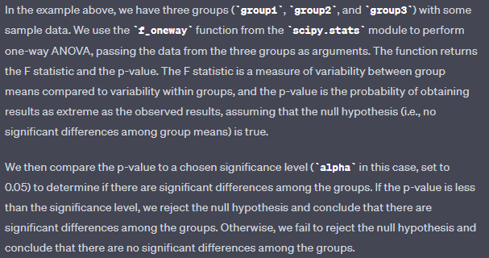

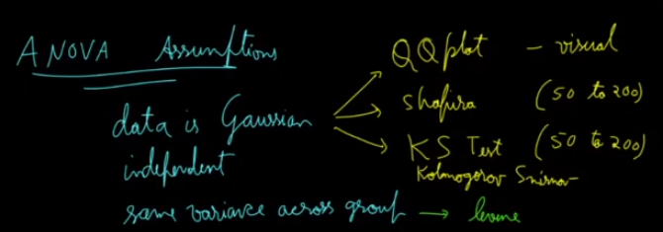

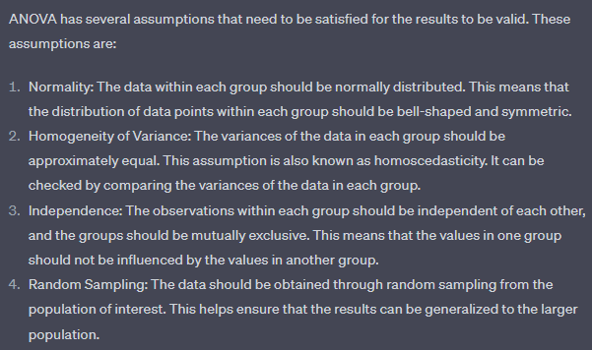

Most used…

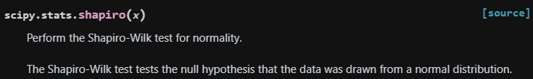

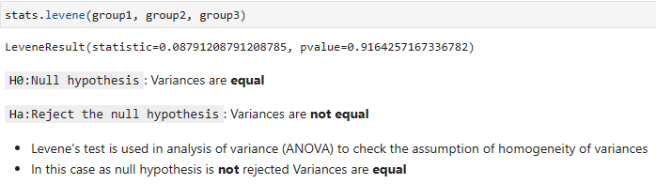

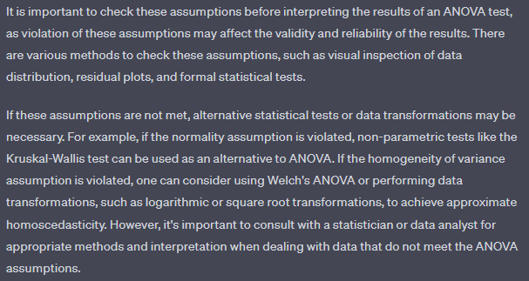

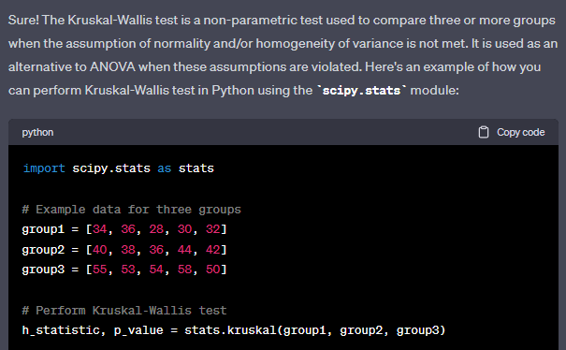

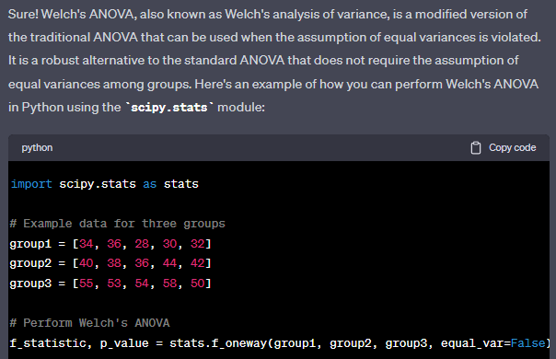

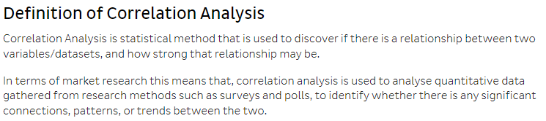

*Remember: Correlation ≠ Causation

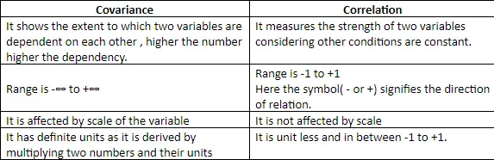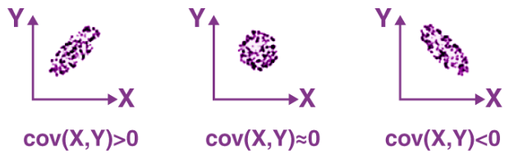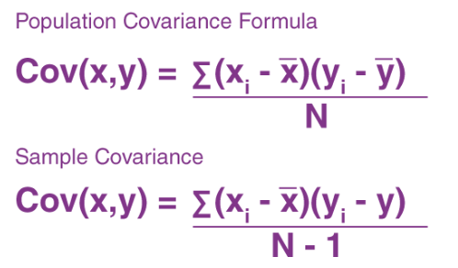

* Pearson correlation

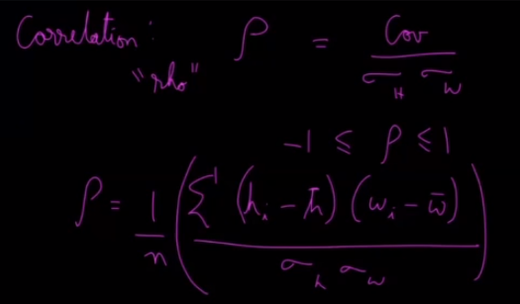

Below are the examples for 2 or more than 2 datasets using pandas or numpy: -

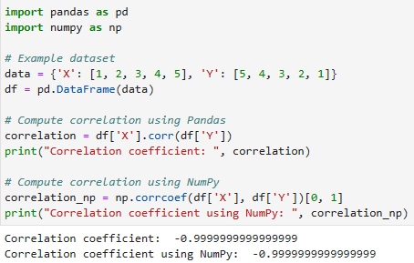

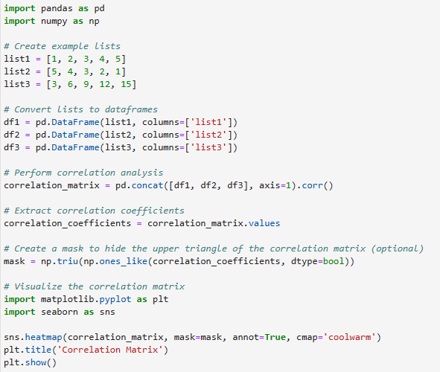

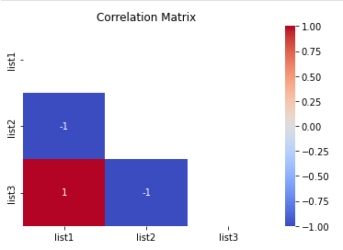

* Spearman's Rank Correlation: Spearman's rank correlation measures the strength and direction of association between two ranked variables. It basically gives the measure of monotonicity of the relation between two variables. Monotonicity of a relation refers to the consistent trend or pattern of change between two variables.

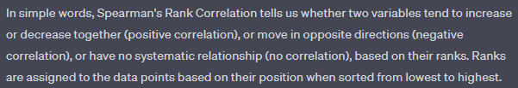

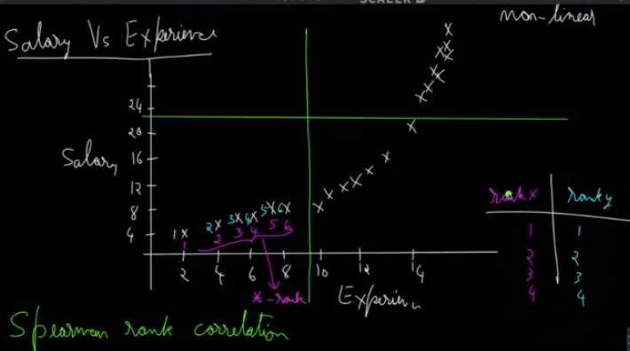

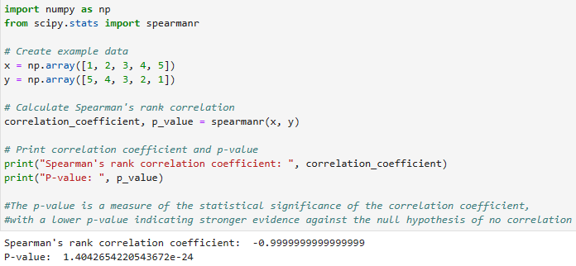

Spearman's Rank Correlation is suitable for non-normally distributed data, monotonic relationships, or when outliers are present, while Pearson's correlation coefficient is appropriate for normally distributed data, linear relationships, and when there are no outliers or influential observations